eOrange: New color-stable, cost-effective PA color masterbatch for E-mobility
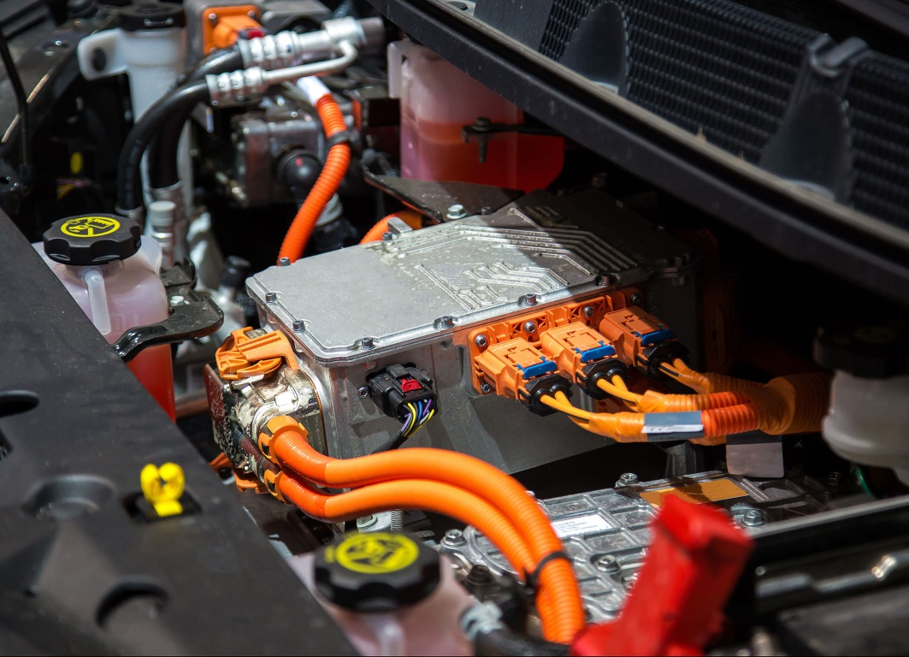
Injection-molded and extruded polyamide components for E-mobility are typical applications for the color-stable and cost-effectively processable eOrange masterbatches jointly developed by GRAFE and Brüggemann. © GRAFE
Heilbronn and Blankenhain/Germany, July 2021 – The striking pastel orange RAL2003 is increasingly being used to identify plastic-sheathed, high-voltage, current-carrying components in E-mobility to warn of the dangers associated with this new technology. eOrange is a color masterbatch for polyamides jointly developed by Brüggemann, Heilbronn, and GRAFE, Blankenhain, which, even after 1,000 hours’ service at 130°C, still retain their warning effect without darkening. In comparison with preformulated compounds, eOrange offers processors considerable flexibility in meeting specific requirements and at the same time optimizes material consumption.
This new GRAFE eOrange masterbatch, known by the trade name PA-Tekolen, can be used for PA6, PA66 and glass fiber-filled and flame-retardant polyamides while maintaining mechanical material properties. Its flexible rate of addition enables distinctly better control over this “critical” color than do commercially available compounds. Its performance is based on a combination of highly thermally stable dyes with special heat stabilizers developed by Brüggemann for polyamides. Possible applications include high-voltage connectors, insulation for high-voltage cables, cable conduits, charging sockets or fasteners for electric vehicles, while wiring harness clips are already in series production. Formulations for other polymers are available on request.
As Lars Tonnecke, GRAFE’s Head of Sales who is playing a key role in the development of GRAFE eOrange, explains: “In line with current trends, we, like our long-standing partner Brüggemann, have been receiving increasing numbers of inquiries from the E-mobility sector for some time now. And that's why we started work on this joint project in late 2019. Brüggemann’s high-performance heat stabilizers and its know-how protect the polymers from unwanted changes, while GRAFE contributes its expertise in coloring and upgrading plastics. Customer benefits include ease of use of the masterbatches when tailoring individual applications and associated flexibility and cost advantages.”
GRAFE is the first point of contact for the use and distribution of eOrange. A specialist in high-performance heat stabilizers and other functional additives for polyamides, including flow improvers and light stabilizers, Brüggemann can also provide advisory support and supply small volumes for the custom development of specific applications.
In addition to color and additive masterbatches, GRAFE’s product range also includes a wide range of functional polymer compounds. One of the sector’s largest research and development departments is working on cutting-edge technologies to equip polymers with smart functions. Founded in 1991 by the four Grafe brothers, this family business today has over 300 staff developing and manufacturing products for national and international markets in the company’s ultra-modern plant in Blankenhain in Thuringia, central Germany. GRAFE attaches great importance to quality management - and does so with great success, being certified to ISO 9001:2015, IATF 16949:2016 and ISO 50001:2011. More information: www.grafe.com
L. Brüggemann GmbH & Co. KG, an independent family owned company headquartered in Heilbronn (Germany), offers tailor-made solutions in the areas of polymer additives, industrial chemicals and ethanol. With more than 250 employees, Brüggemann specializes in the development and production of reducing agents on the basis of sulfur, zinc derivatives, AP-NYLON® Additives and high-performance additives for polyamides and polyester. Furthermore, Brüggemann is an innovative partner in the field of ethanol, for example in the pharmaceutical, chemical and cosmetic industries, as well as in the area of disinfectants. Founded in Heilbronn in 1868, Brüggemann now supplies customers in more than 60 countries. With subsidiaries in Lutherstadt Wittenberg, the USA and Hong Kong, the company has an annual turnover of over 150 million EUR.

Editorial contact and please send voucher copies to:
For GRAFE:  GRAFE Advanced Polymers GmbH  Manfred Fischer Tel. +49(0)36459-45-287  Waldecker Str. 21 Fax 036459-45-145  D-99444 Blankenhain manfred.fischer@grafe.com | For Brüggemann:  Konsens PR GmbH & Co. KG, www.konsens.de  Dr.-Ing. Jörg Wolters Tel. +49(0)60 78-9363-0  Im Kühlen Grund 10 D-64823 Groß-Umstadt  joerg.wolters@konsens.de
Text and image of this press release are available for download at www.konsens.de/brueggemann.html

